Enrollment & Retention Management Update - December 2025
12/2/2025

Dear Campus Community,

Please find attached the Enrollment & Retention Management Update for December 2025. In addition to reporting enrollment targets, we are also providing a list of important dates and recruitment activities. Feel free to reach out if you have any questions or need more information.

Enrollment:
This chart below reflects our Spring 2026 numbers as of December 2, 2025.
In addition, I've attached the CUNY Dashboard Report, also dated 12-2-25.
This report compares our enrollment with the other CUNY colleges.
Please note there has been a slight adjustment to the Spring 2026 enrollment targets to align with the financial targets that were submitted to CUNY.

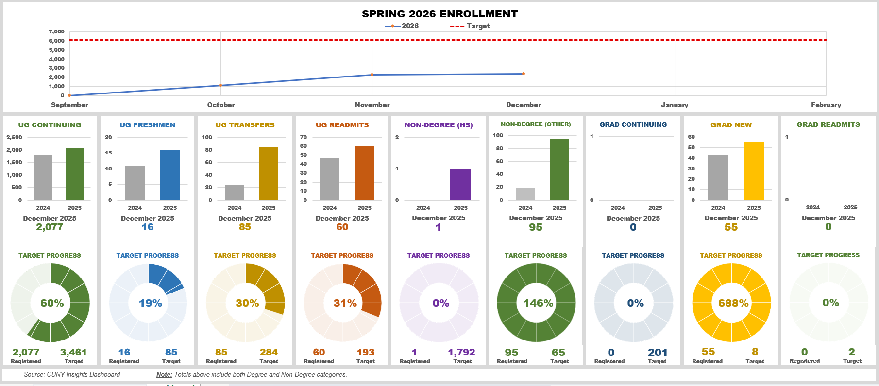

Enrollment and Retention Reminders:
Readmission Fee - the college is waiving the $20 readmission fee for Spring 2026 to remove that financial barrier for students who wish to return.

Admissions Funnel
The admissions funnel indicates the number of student applications vs admitted vs committed to the college as compared to last year.
Admissions staff work on contacting students to help them move through the funnel.
12/2/2025 | SP26  Apps | SP25 Apps | % change | SP26  Admits | SP25 Admits | % change | SP26  Commits | SP25 Commits | % change
FTF | 1,083 | 1,108 | -2.3% | 101 | 206 | -51.0% | 28 | 39 | -28.2%
Transfer | 1,729 | 1,653 | 4.6% | 705 | 738 | -4.5% | 236 | 202 | 16.8%
Total | 2,812 | 2,761 | 1.8% | 806 | 944 | -14.6% | 264 | 241 | 9.5%

Class Sections by Modalities - Comparison
Compares the number of class sections by modalities: In person, Hybrid and Online.
Term | In Person | Hybrid | Online | TOTAL
Spring 2025 | 639 | 304 | 517 | 1460
Spring 2026 | 640 | 322 | 531 | 1493

Important Dates:
Monday, December 15, 2025 | Last day for classes
Monday, December 15, 2025 | Last day for INC grade changes for Spring 2025 and Summer 2025 to be received by the Office of the Registrar
Monday, December 15, 2025 | Last day to RESCIND Pass/Fail Option
Tuesday, December 16, 2025 | Final Examinations
Wednesday, December 17, 2025 | Final Examinations
Thursday, December 18, 2025 | Final Examinations
Friday, December 19, 2025 | Final Examinations
Saturday, December 20, 2025 | Final Examinations
Sunday, December 21, 2025 | Final Examinations
Monday, December 22, 2025 | Final Examinations
Monday, December 22, 2025 | End of Fall 2025 term
Wednesday, December 24 - Thursday, December 25 | College is closed
Thursday, December 25, 2025 | College is closed
Friday, December 26, 2025 | Final grade submission deadline
Friday, December 26, 2025 | Last day to file ePermit request for Winter 2026 Session.
Wednesday, December 31, 2025 | College is closed

Financial Aid Filing Sessions
Overview: Financial Aid staff will be available to assist students with filing the Financial Aid application and answer any questions.
When: Every Tuesday and Thursday 12-2pm
Where: In the area directly across from the Welcome Center

Recruitment Events
December Events – We encourage faculty, staff, and alumni to join the Admissions Counselors on all recruitment events listed below. If you are interested in participating, please contact Anthony Davis at adavis13@york.cuny.edu
Date and Time | Time | Name of Event
Wednesday, December 3, 2025 | 10:00 AM | P2G - Brooklyn
Wednesday, December 3, 2025 | 10:00 AM | Pathway to Graduation - Richmond Hill High School
Monday, December 8, 2025 | 5:00 PM | Pan American International High School
Wednesday, December 10, 2025 | 11:00 AM | Pathway to Graduation - John Adams High School

