Enrollment & Retention Management Update - November 2025
11/1/2025

Dear Campus Community,

Please find attached the Enrollment & Retention Management Update for November 2025. In addition to reporting enrollment targets, we are also providing a list of important dates and recruitment activities. Feel free to reach out if you have any questions or need more information.

Enrollment:
This chart below reflects our Spring 2026 numbers as of November 1, 2025.
In addition, I've attached the CUNY Dashboard Report, also dated 11-1-25.
This report compares our enrollment with the other CUNY colleges.
Please note there has been a slight adjustment to the Spring 2026 enrollment targets to align with the financial targets that were submitted to CUNY.

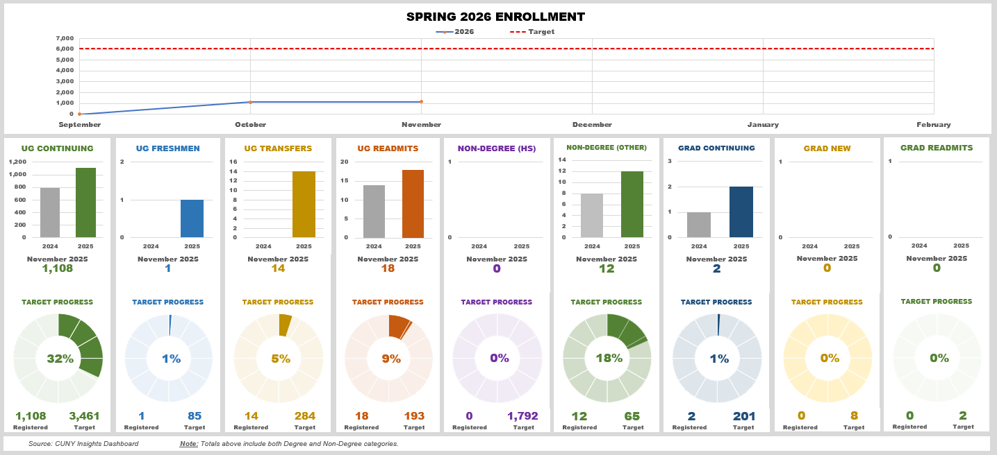

Enrollment and Retention Reminders:
Admissions Application Fee - CUNY is waiving the Admissions Application Fee. See dates below:
- New York City Public Schools (NYCPS) - Oct. 27 - Nov. 21
- Non-NYCPS including Yeshivas and Private schools - Nov. 11 - Nov. 21
Readmission Fee - the college is waiving the $20 readmission fee for Spring 2026 to remove that financial barrier for students who wish to return.

Admissions Funnel
The admissions funnel indicates the number of student applications vs admitted vs committed to the college as compared to last year.
Admissions staff work on contacting students to help them move through the funnel.
11/1/2025 | SP26  Apps | SP25 Apps | % change | SP26  Admits | SP25 Admits | % change | SP26  Commits | SP25 Commits | % change
FTF | 786 | 779 | 0.9% | 87 | 98 | -11.2% | 12 | 7 | 71.4%
Transfer | 1,362 | 1,320 | 3.2% | 600 | 511 | 17.4% | 123 | 81 | 51.9%
Total | 2,148 | 2,099 | 2.3% | 687 | 609 | 12.8% | 135 | 88 | 53.4%

Class Sections by Modalities - Comparison
Compares the number of class sections by modalities: In person, Hybrid and Online.
Term | In Person | Hybrid | Online | TOTAL
Spring 2025 | 639 | 304 | 517 | 1460
Spring 2026 | 632 | 251 | 521 | 1404

Important Dates:
Wednesday, Nov. 5 | R2T4 60% date for the term
Thursday, Nov. 6 | Last day to APPLY for Pass/Fail Option
Thursday, Nov. 6 | Course Withdrawal period ends. Last day to withdraw from a course(s) WITH a grade of W without Committee on Academic Policy and Standards approval
Monday, Nov. 17 | Last day to file for Spring 2026 Graduation
Friday, Nov. 21 | Last day of Admissions Application Waiver
Thursday, Nov. 27 | College is closed – No classes scheduled
Friday, Nov. 28 | College is closed – No classes scheduled
Saturday, Nov. 29 | No classes scheduled
Sunday, Nov. 30 | No classes scheduled

Admissions Information Session
Overview: This session will provide an overview of the three schools, financial aid, admissions process and timelines, and finally questions and answers.
Register in advance for this meeting: FRIDAY, NOVEMBER 7th, 3:00 p.m. to 4:00 p.m.
Register in advance for this meeting: FRIDAY, NOVEMBER 14th, 3:00 p.m. to 4:00 p.m.

Financial Aid Filing Sessions
Overview: Financial Aid staff will be available to assist students with filing the Financial Aid application and answer any questions.
When: Every Tuesday and Thursday 12-2pm
Where: In the area directly across from the Welcome Center

Recruitment Events
November Events – We encourage faculty, staff, and alumni to join the Admissions Counselors on all recruitment events listed below. If you are interested in participating, please contact Anthony Davis at adavis13@york.cuny.edu
Date | Time | Name of Event
Wednesday, November 5, 2025 | 8:00 AM | DeWitt Clinton High School
Wednesday, November 5, 2025 | 5:30 PM | Pathways College Preparatory School College Fair
Thursday, November 6, 2025 | 11:30 AM | Maspeth High School
Thursday, November 6, 2025 | 3:30 PM | KIPP NYC College Prep Info Sessions 2025
Thursday, November 6, 2025 | 7:00 AM | Valley Stream Central High School
Friday, November 7, 2025 | 8:00 AM | 2025 Fall CUNY Counselor Conferences
Friday, November 7, 2025 | 9:00 AM | UFT College Fair
Saturday, November 8, 2025 | 12:00 PM | Advancing MY Future College & Vocational Career Fair
Sunday, November 9, 2025 | 12:00 PM | OPEN HOUSE
Monday, November 10, 2025 | 9:00 AM | John Adams H/S College Fair
Wednesday, November 12, 2025 | 9:30 AM | Al-Madinah School College Fair 2025
Wednesday, November 12, 2025 | 9:30 AM | Dr Susan S Mckinney Secondary School Of The Arts
Thursday, November 13, 2025 | 12:00 PM | Invitation to Visit HPHS
Thursday, November 13, 2025 | 5:30 PM | Boys and Girls Club of Metro Queens
Friday, November 14, 2025 | 11:00 AM | Partnership Opportunity – College Fair Outreach
Wednesday, November 19, 2025 | 9:00 AM | Hart High School
Wednesday, November 19, 2025 | 10:00 AM | Kingsborough CC Private visit
Thursday, November 20, 2025 | 11:00 AM | St. Vincent Ferrer High School
Friday, November 21, 2025 | 9:00 AM | Alfred E. Smith College and Career Fair

