User Guide
February 2022 v3.1.5

Introduction 3
Welcome Message 4
Welcome Screens 4
Health Survey 6
Symptom Checker Reminder 8
Viewing Your Access Pass 9
User Dashboard 10
Book Covid Test Appointment 10
Connect Test Kit ID 12
Upload Covid-19 Test Proof 12
Enter Your Vaccination Data 13
Connect Your Vaccination Health Data 16
Connect Your Test Health Data 16
Decline To Provide Vaccine Proof 17
Upload Daily Temperature Reading 17
Dashboard Menu 18
Your Health Data 18
Appointment Information 19
Your Personal QR Code 20
Setting Your Preferred Language 20
Personal Settings 20

Introduction
Welcome to CLEARED4, an easy way to screen for possible Covid symptoms and track your Covid-19 tests and vaccination status.

There is no app to download and no username or passwords to remember. We hope you will find it very simple to use.

Welcome Screens
Your organization may require you to enter personal information to continue. This information is required by your state. After you have entered your information, click Save.
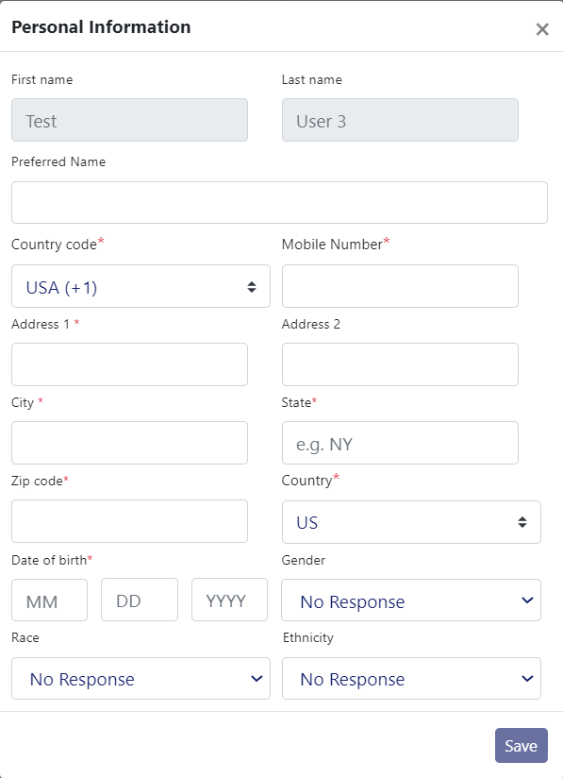

You may also be asked to accept a disclaimer, upload a photo or insurance card, or upload test or vaccination information. Please complete these items to continue.

Disclaimer | 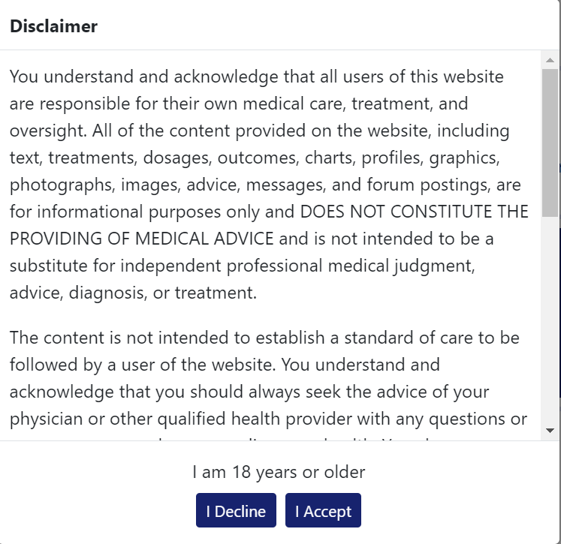
Upload Profile Picture | 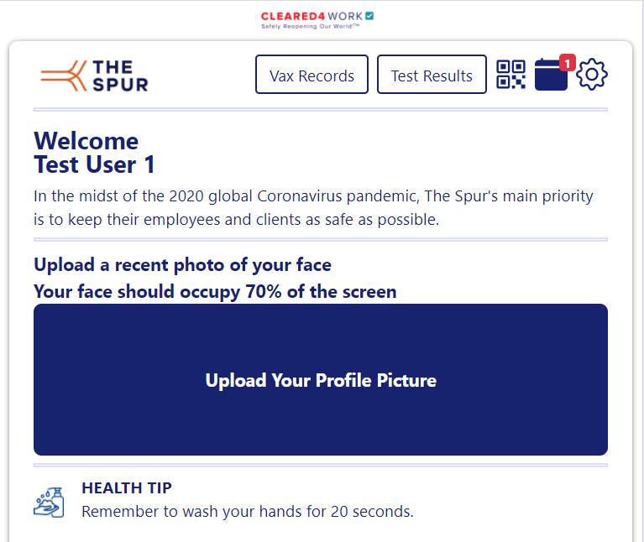

Viewing Your Access Pass
You can view your access pass by clicking the Show Access Pass button. The color of your pass may vary, depending on your organization.

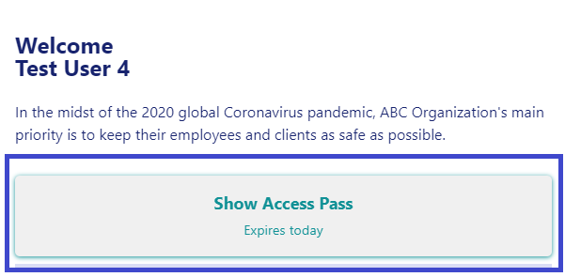 | 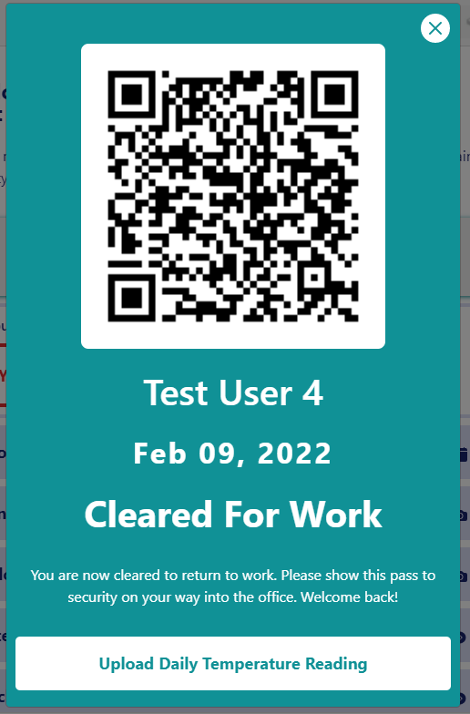

User Dashboard
Your organization may request additional information from you. Depending on the information your organization would like, some or all of the options may display.
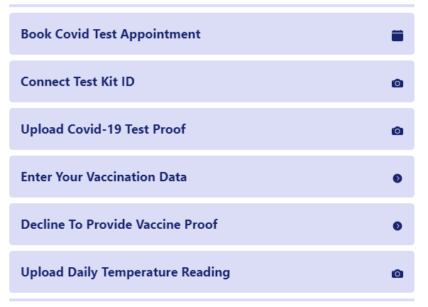

Dashboard Menu
The dashboard menu is located in the upper left corner of the screen. Click on the menu to display the selections available to you.
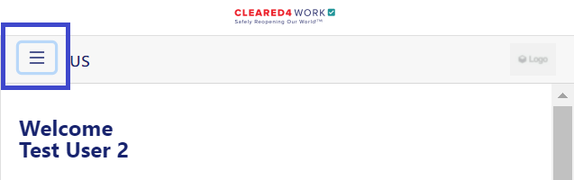

Your Health Data
Once you have uploaded your vaccine card and receive your test results, you can access them by selecting Vaccination Records or Test Results from the menu in the upper left corner of the screen.
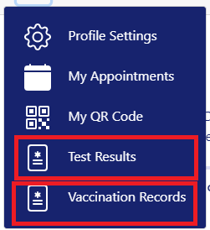

As a security measure, when accessing your test results you will be sent a one time text code to access your health information.
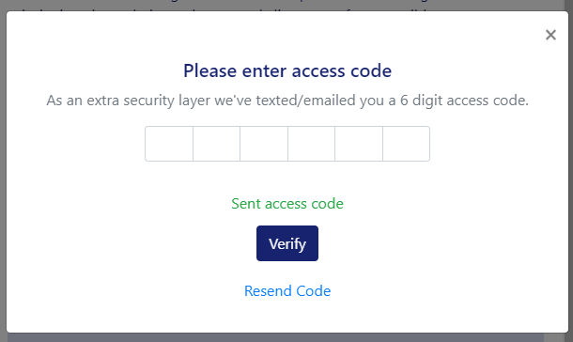

This will give you the convenience of having a secure way to show health records digitally.
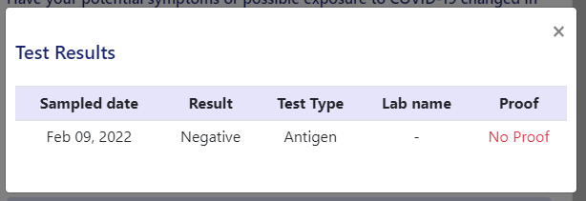

Appointment Information
Select My Appointments to see your upcoming appointments.
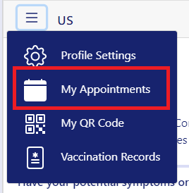

You can delete a scheduled appointment by clicking the garbage can icon, then confirming the delete.
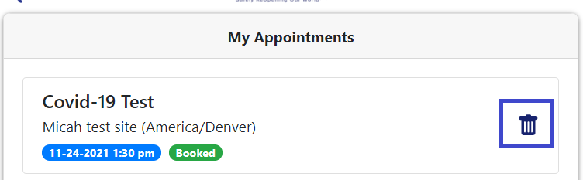

Your Personal QR Code
Select My QR code to access and display your personal check in code.
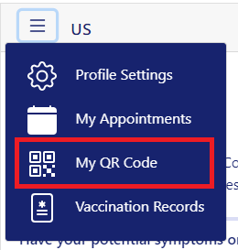

Setting Your Preferred Language
You can choose what language you would like the display the app in by clicking the button to the right of the menu, then selecting your preferred language.

Note: This example displays only two languages. Your organization may have more language options available.
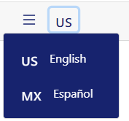

Personal Settings
You can access your profile page by selecting Profile Settings.
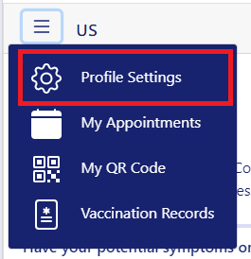

Use this screen to add a photo, or edit your Preferred Name, Phone Number, Email, Reminders preference and Reminder Time.

Click Save after making any changes.
