This job aid instructs requesters and creators on how to Create and Manage Requisitions in CUNYfirst.

Create Requisitions
Step | Action
From the CUNYfirst home page https://home.cunyfirst.cuny.edu), log in to CUNYfirst production.

Click on the Financials Supply Chain link in the menu on the left hand side of the page.

 | It is highly recommended that you perform the Budget Overview query before entering a requisition. Click on the Reporting Tools link.
 | Click on the Query link.
 | Click on the Query Viewer link.
Search for the Budget Overview (for State funds) query by entering CU_FS%BUDGET% in the blank field to the right of Query Name search box. If you have defined the query as one of your favorites, it will already be displayed on the page. The query name for this report is CU_FSPO_STA_BUDGET_OVERVIEW.

Click the Search button.

Click ‘Add to Favorites’ to add the Query to ‘My Favorite Queries’.
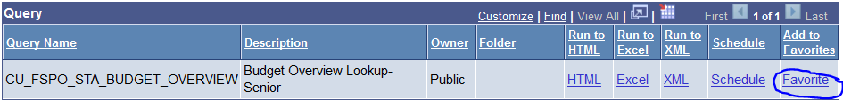

Click the HTML or Excel link that displays to the right of the query name. The next page that displays allows criteria to be input. Enter 2014 as the Budget Period and use the xxx01 as the (GENERAL LEDGER) Business Unit. Enter your 5-digit Department, the Fund Code (10 or 11 as appropriate) and % in the Major Purpose field (or Major Purpose if known). Click the View Results button. See the Available Budget in the appropriate report column.

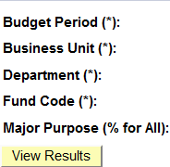

NOTE: If there are multiple lines, the available budget noted on each line is not the cumulative of all the lines. The entire budget appears on every line associated with the code.

If there are not sufficient funds, contact the person who handles the budget in your department.
To return to the CUNYfirst menu, click the Query Viewer tab on the top of your screen.

Note: Never use the browser back button to go back to a page while in CUNYfirst.
 | Click the eProcurement link.
 | Click the Create Requisition link in the menu or on the dashboard that displays.
If you are a creator for more than one person, you will be presented with a list of requester names. Click on the person for whom the requisition will be built.

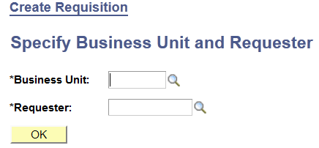

The page that displays is the Define Requisition page that will show the requester’s purchasing Business Unit (xxxPR for state tax levy transactions), the Requester ID and name, and a Priority of Medium.

Although the Priority can be changed to High or Low by clicking on the drop down arrow in the right hand corner of the field, this designation does not do anything systematically. It is for information only.

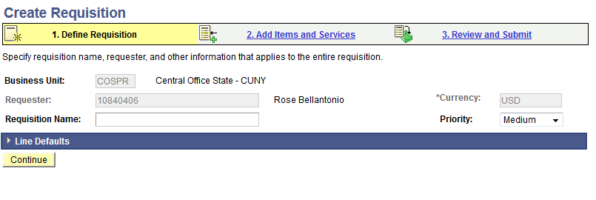

The Requisition Name is for the creator’s convenience when searching for and retrieving requisitions from Manage Requisition lists. It only displays to the requester/creator and does not carry on throughout the requisition lifespan in other documents (e.g., PO, voucher). Although not a required field, it is highly recommended that a Requisition Name be entered.

Requisition Name:
 | Click the Continue button or the Add Items and Services link on the top of the page. See Step 11 for page shot.
The Create Requisition page displays. Because CUNYfirst does not use product catalogs, every requisition is a Special Request. Note that the Special Request tab is dark blue while the other tabs (Favorites, templates, etc.) that display are light blue. If this page does not default, click on the Special Request tab to access it. Once you do this, the Special Request page should default.
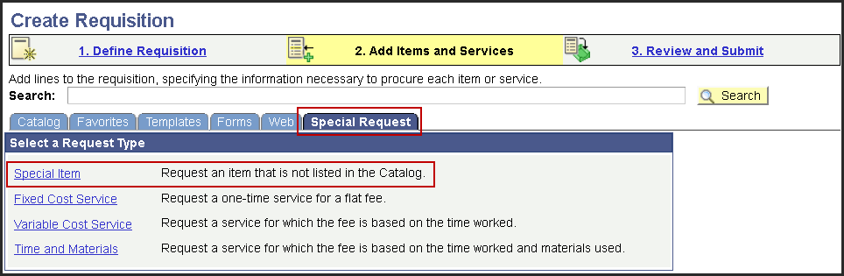
 | Click the Special Item link in the Special Request tab.
The fields that display are used to build a requisition line. Fields with asterisks are required.

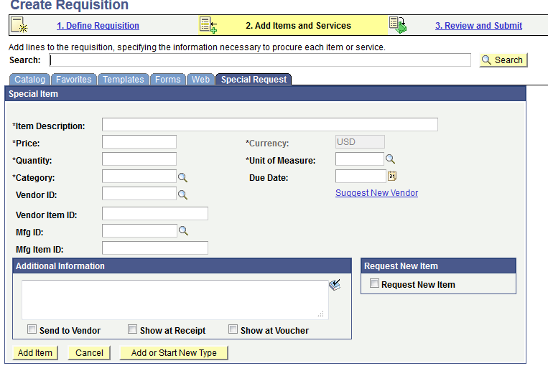

Add an *Item Description. This description displays on the purchase order and should be as detailed as possible.

Click in the Item Description field.
*Item Description:
Add a *Price. Use only digits and decimal points; do not use dollar signs or commas.

*Price:
Add a *Quantity.

Note: For a blanket requisition or any dollar-based line (services, intangibles, etc.), the Quantity will always equal 1.

*Quantity:
Add a *Unit of Measure (UOM). Click on the look up icon to the right of the field to see the valid values for UOM. Be as specific as possible to ensure that the receiver can conduct the receipt of goods in a meaningful way (e.g., using BOX may be ambiguous.)

Note: For a blanket requisition or any dollar-based line (services, intangibles, etc.), the UOM will always equal EA (Each).

*Unit of Measure:
 | Adding a Due Date is possible but it is for information only. It does not do anything systematically
Add a *Category Code (formerly called Commodity Code). Click on the look up icon (see Step 16 for page shot) to the right of the field to see the valid values for Category Code. To search with a phrase, use the drop down box to change the search criteria to Description. To search with a number, use the drop down box to change the search criteria to Category. Click the Find button and choose the appropriate code by clicking on the Category hyperlink.

NOTE: Be very general in your Category Code selection. Procurement, using your detailed description of the item, will change the code if it is not appropriate. For example, use Office Supplies instead of searching for “Bottled Water” or “Copy Paper”.
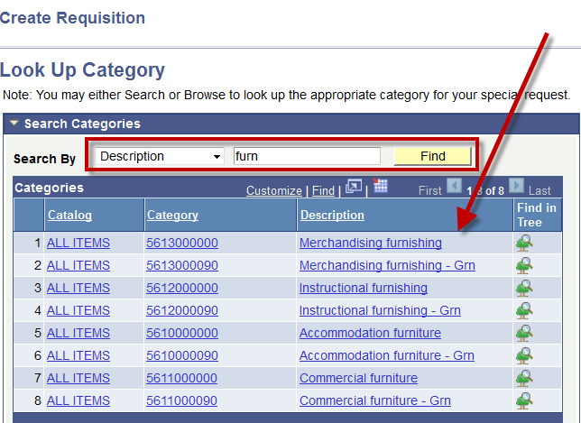

This code routes the expense to the correct expense code (now called Account code in CUNYfirst) and requires an inspection if the category is for hazardous materials, furniture, facilities, IT-related purchases.
*Category Code:
Although Vendor ID is not a required field, a vendor ID can be entered on the requisition. However, rather than choosing a vendor here, it is recommended that you put your vendor’s name in the comments and allow Procurement to get the correct vendor id in the requisition and purchase order.

Note: Ultimately, it is the Business Unit Purchasing Office that determines the final vendor. Don’t enter a vendor unless it is clear cut and known. In order for Purchasing to create a Purchase Order, the CUNYfirst Vendor ID must also have a valid Statewide Financial System (SFS) Vendor ID for State Funded Purchase Order or a valid Financial Management System (FMS) Vendor ID for City Funded Purchase Order.

Vendor ID:
If the vendor you are searching for is not there, they cannot be paid for their goods or services. Using the Suggest New Vendor link will not accomplish getting their record into CUNYfirst.

Call or email the Vendor Management Unit at Central Office (212-397-6505 or 212-397-5633) to assist you in adding a new vendor.
If comments are appropriate, enter them in the Additional Information field. To print the comments on the purchase order, click the Send to Vendor check box. For internal comments only leave the boxes unchecked or click the Show at Receipt and/or Show at Voucher boxes. This is a completed page:
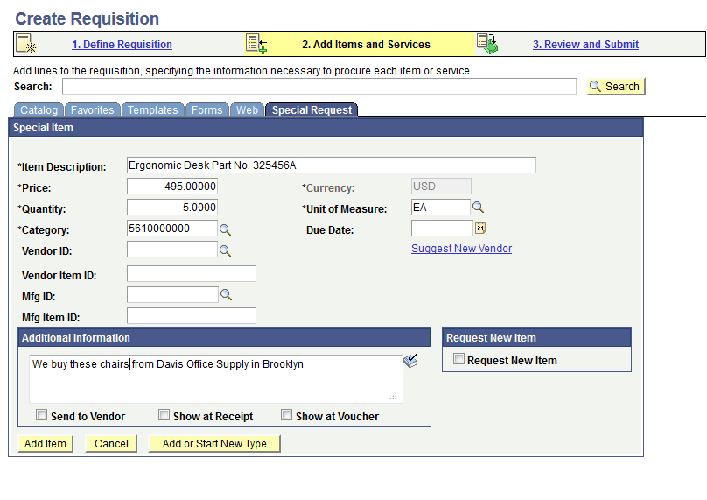
Once the above steps are complete, click on the Add Item button. The Requisition Summary that displays under the menu on the left hand side of the page will update and the fields on the page will reset to blank.

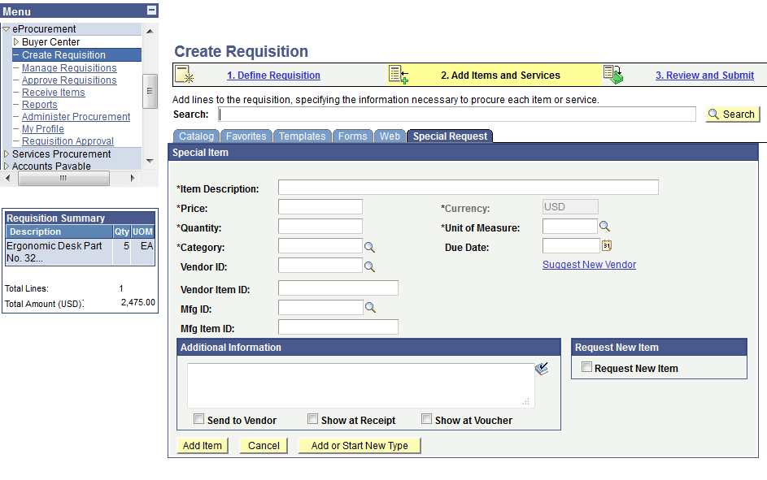

Add subsequent lines if more items are required.

NOTE: ALWAYS add a Shipping Line to cover freight charges if the shipping cost is not included in the Price of the goods. Use the following values for the Shipping line:

- Price = lump sum dollar amount of the shipping as estimated by the vendor of the goods
- Quantity = 1
- Unit of Measure = EA
- Category Code = 7810000000 (Mail & Cargo)
- Use the same Vendor ID as the other item(s) on the requisition.
- any relevant comments

Click the Add Item button after entering each line and ensure that the Requisition Summary updates.
 | When all lines of the requisition have been entered, click on the Review and Submit link at the top of the page
The Create Requisition page displays with all of the lines of the requisition just entered. Click on the Save and preview approvals button to save the requisition and review the approval workflow.

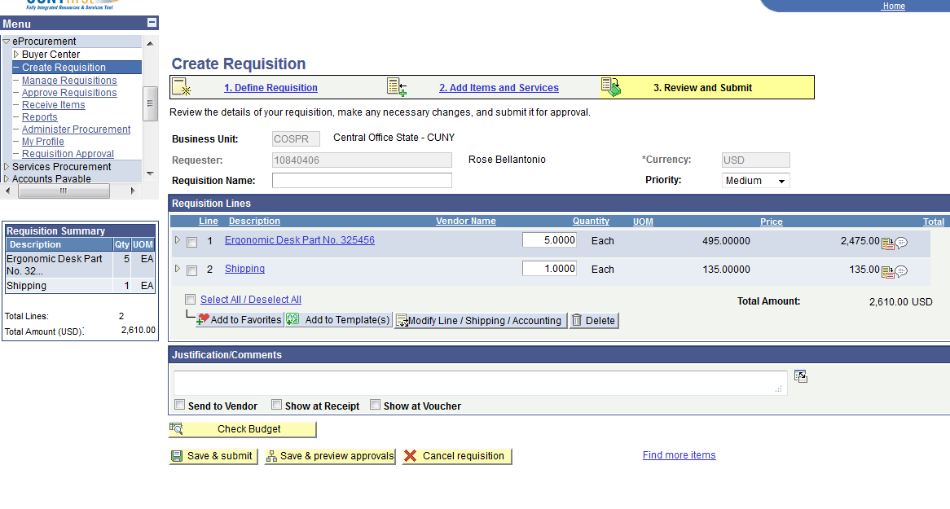
The approval workflow will display for your review only. The requisition has not been formally entered into the workflow; this is only a preview.

The name(s) of the approvers will be hyperlinked. If clicked, the email address will be displayed. If approvers are pooled at department levels, click the Multiple Approvers link to see the names and email addresses for all the Approvers at this level.
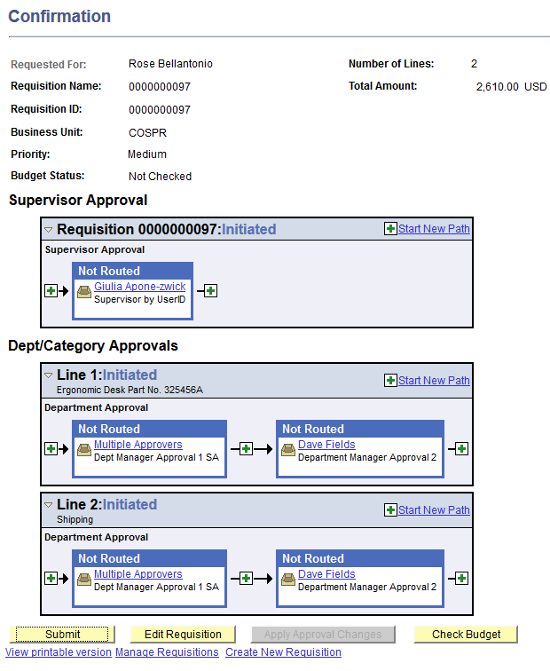
 | Click the Edit Requisition button to return to the requisition.
NOTE: Every shipping line and all lines that represent a dollar lump sum amount (services, blanket requisitions etc.) must be edited as follows:

Click the check box for the line and click the Line Details icon to the right of the line. The Line Details page displays.
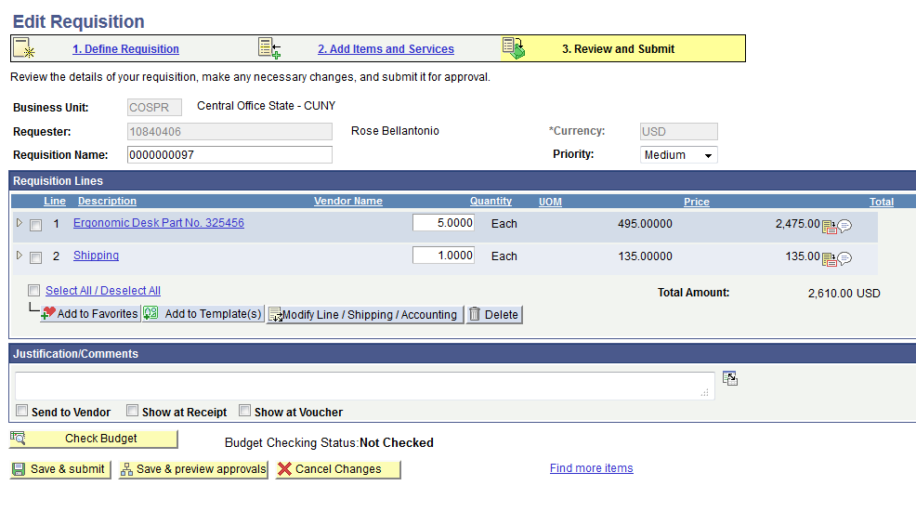

Check the Amount Only check box in the lower right hand corner of the page.

If the Inspection Required box is checked, DO NOT uncheck it. The mandatory inspection has been created from the use of a Category Code that requires an Inspection.

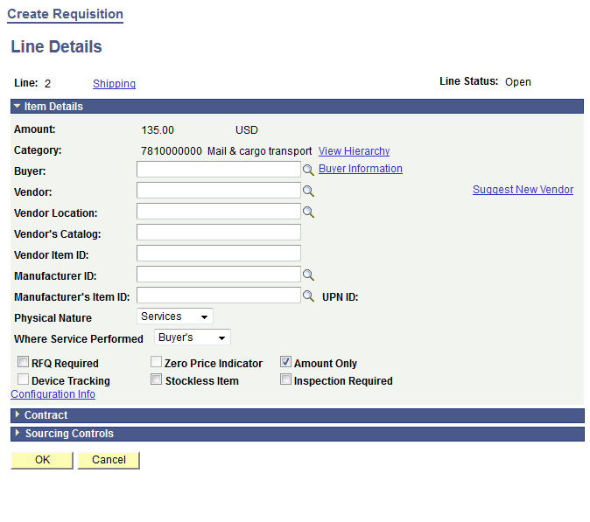

Click the OK button.

A dialogue box will display with a message (not an error). If you have not entered the Quantity as 1 (Quantity = 1 is required for a dollar-based line), it will be entered for you. Click Yes.
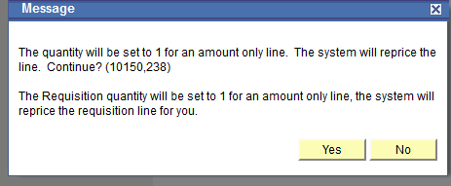

Click the Yes button.
You are returned to the Edit Requisition page. The requisition can be further edited if necessary:
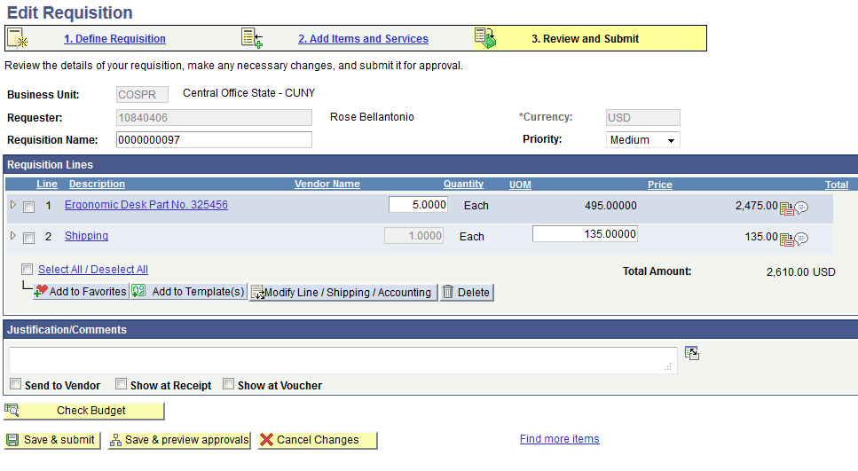

- To delete a line, click the check box for the line and click the Delete button
- Verify General Ledger Business Unit and Location on the Chartfields1 tab; Operating Unit, Fund, Department, Program, Major Purpose and Special Initiative on the Chartfields2 tab; and Fund Source on the Chartfields3 tab. If necessary, make the appropriate changes.
- If necessary, change the Ship To or Location on the Chartfields1 tab.
- To add to Favorites or to add as a Template, select a line(s) and click the appropriate button
- Justification/Comments can be added
- Any changes just made can be cancelled by clicking the X Cancel Changes button
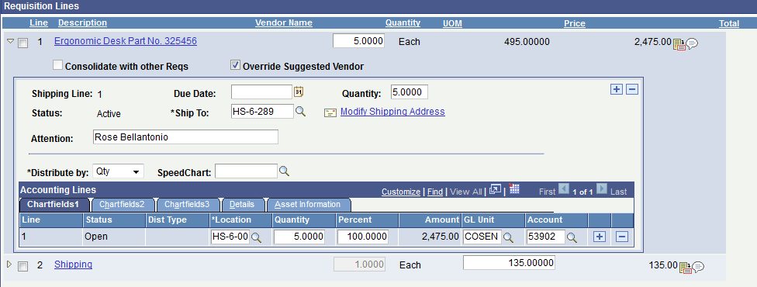

To add or modify comments and upload supporting documentation, click the Comments icon.
Add attachments by clicking on the Add Attachment button.

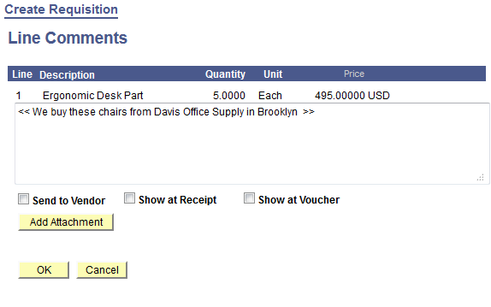
Browse for your file and then click the Upload button.

Click the OK button. You will return to the Edit Requisition page.

When the requisition is done, click on the Save and Submit button. The requisition is now submitted into the approval workflow to the requester’s supervisor.
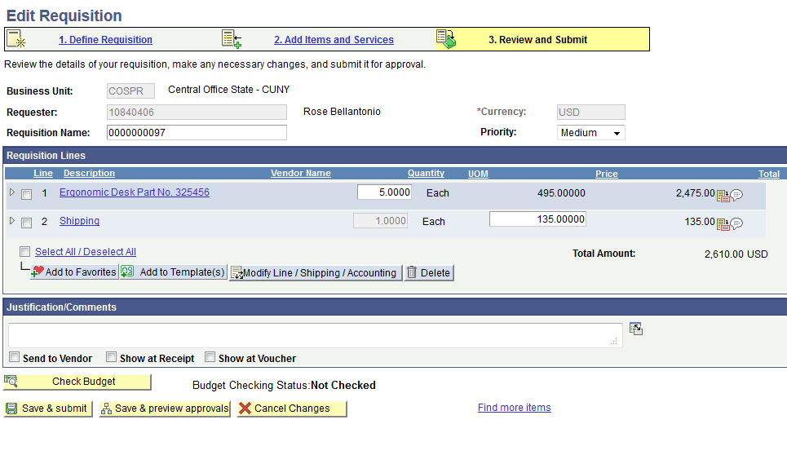

The requisition is now formally submitted to the Approval Workflow. Note that the status of Supervisor approval has changes from Initiated to Pending.
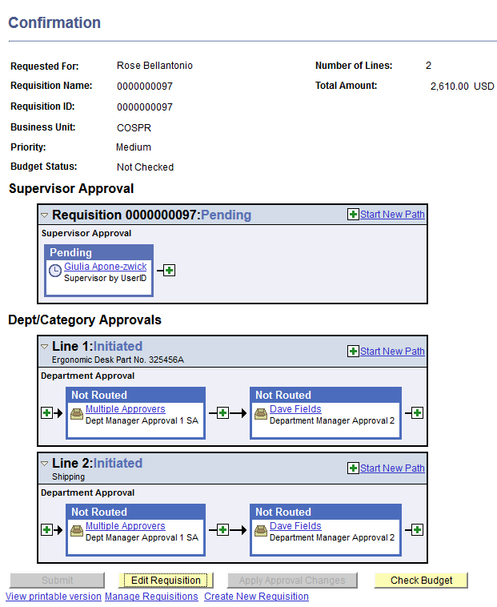

Manage Requisitions

Step | Action
To Manage Requisitions, access the requisitions by:

  - logging in to CUNYfirst production, clicking on the Financials Supply Chain link then eProcurement, then Manage Requisitions links
  - clicking on the Manage Requisitions link after the workflow approval displays (after clicking the Save and Submit button on the Edit Requisition page (see step 35 above)
  - clicking the Manage Requisitions link in the menu

The page that displays is the Manage Requisitions page that will display a search box used to filter the list of requisitions presented. Be sure to select the correct business unit xxxPR. The Request Status “All but Complete” defaults into the field which allows all requisitions that are not complete to display. Choose relevant search parameters if you want or need to filter the list. Click the Search box.

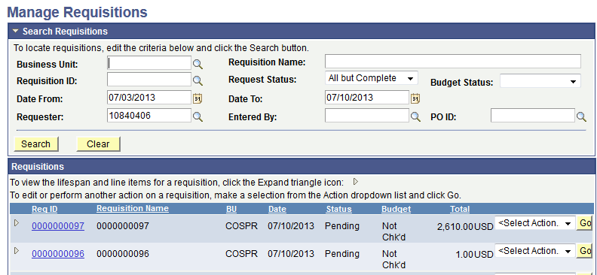

To see the lifespan of a requisition, click on the Expand Section icon to the left of the Requisition ID hyperlink. Any icon in the lifespan that is highlighted can be clicked and the document (e.g., purchase order, receipt, and voucher) will be displayed. This lifespan details where the requisition is in the process from its creation to the payment(s) of related vouchers.
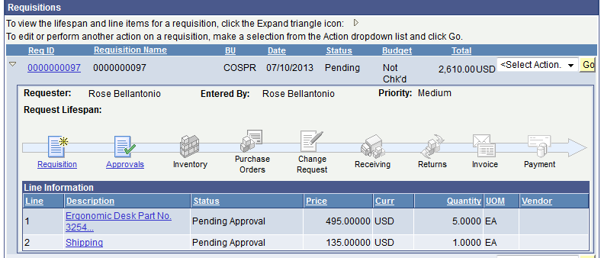
 | To edit or perform another action on a requisition, make a selection from the Select Action dropdown list and click Go. The Budget Check action is available but does not conduct a budget check. The budget check is always performed by the system.

