

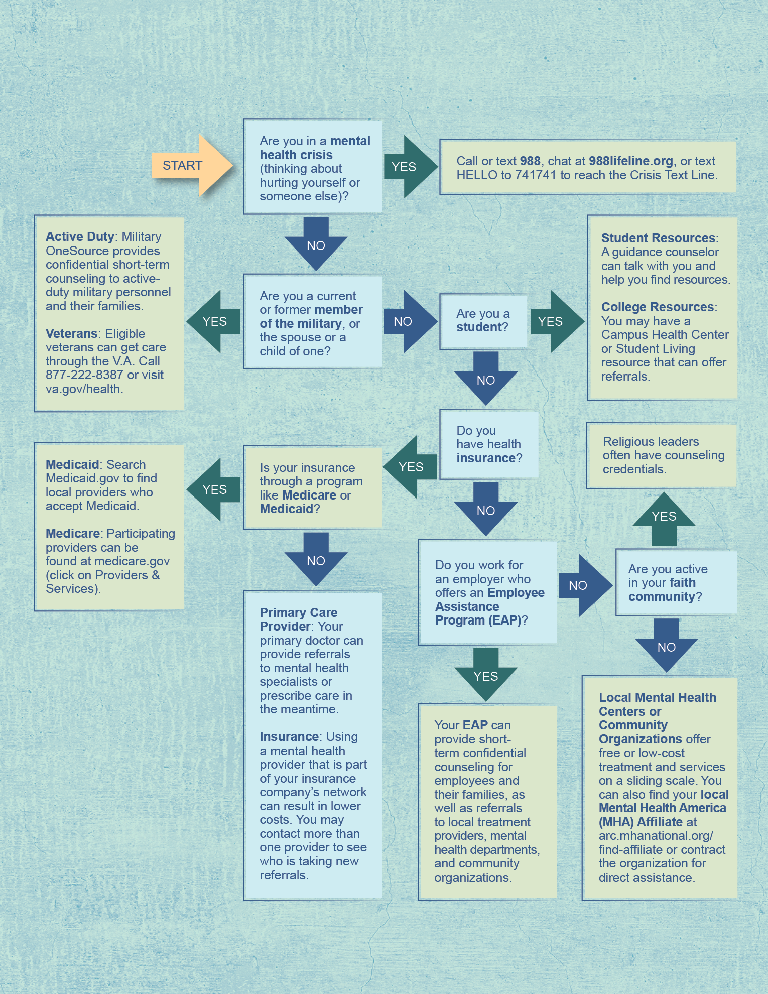
ACCESS LINE: 800-833-8707 | WEBSITE: myccaonline.com
Remember, CCA@YourService--your Employee Assistance Program (EAP)—can help you and those you care about connect to professional counseling for any issue that’s on your mind. Access is free, confidential, and 24/7.
MENTAL HEALTH SUPPORT DECISION MAP:
If you think you might benefit from mental health support, use the map below as a starting point for some direction and resource suggestions.

